WPL LAB 5
name: Abhinav Singh Bhagtana
roll no: A-029
reg no: 230905225

Q2.Create a web form with employee ids in dropdown list. Use a textbox for accepting
date of joining. Add a button named “Am I Eligible for Promotion”. On clicking
the button, if he has more than 5 years of experience, then display “YES” else
“NO” in the label control.
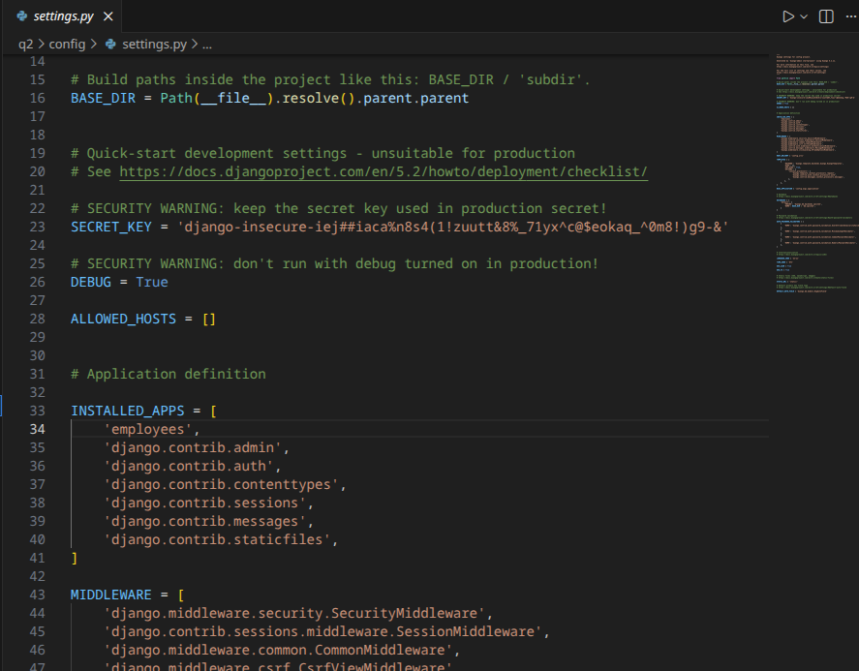
Urls.py
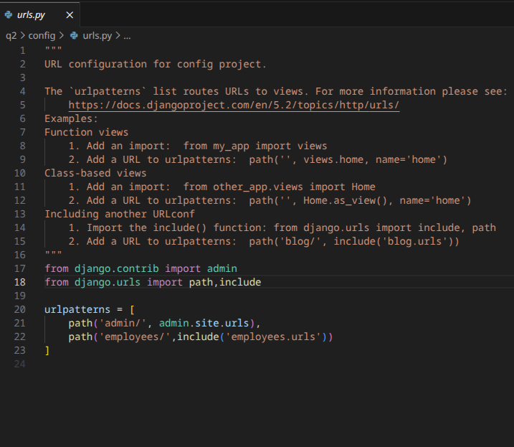
forms.py
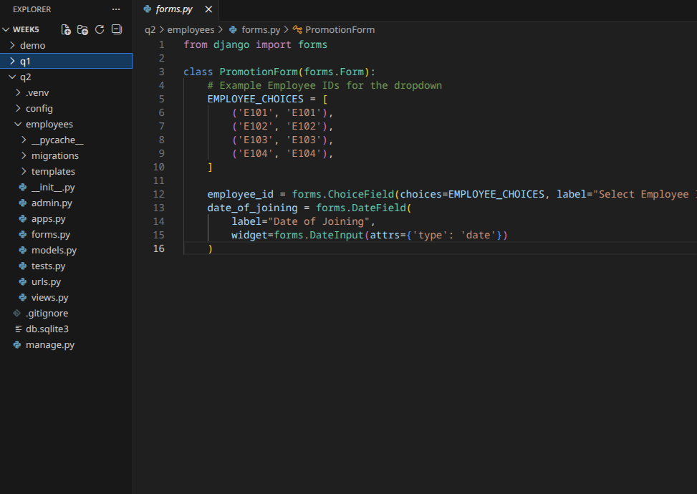
check.html
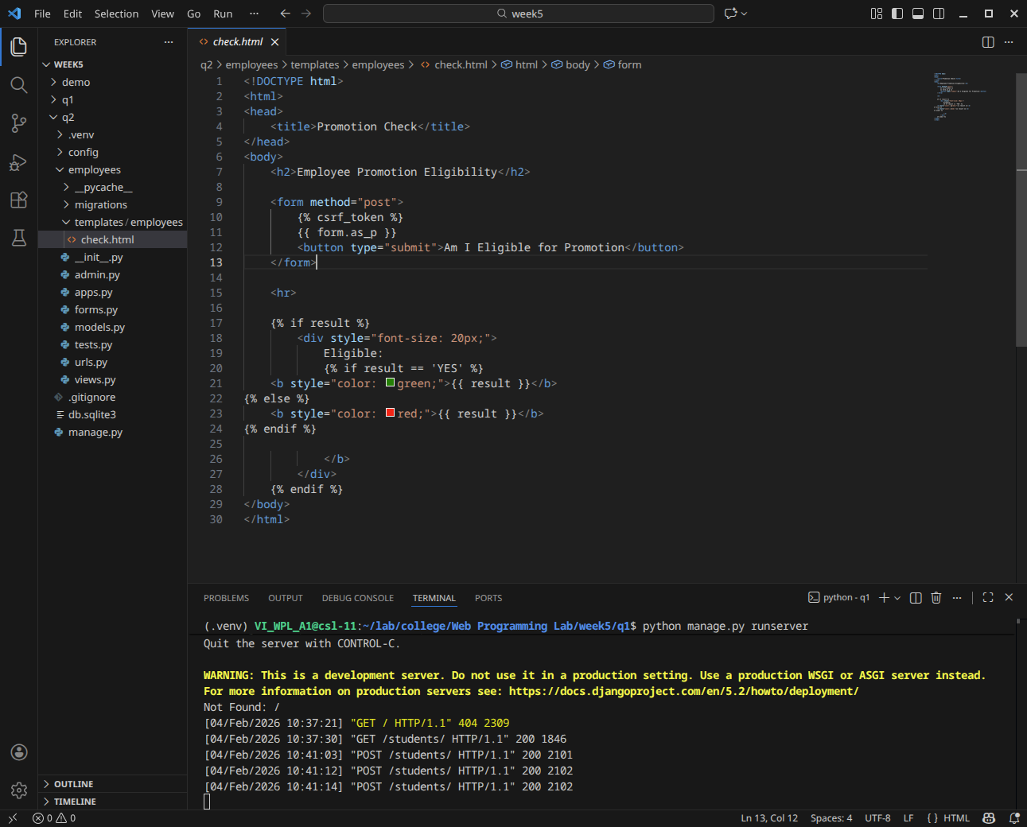
website:
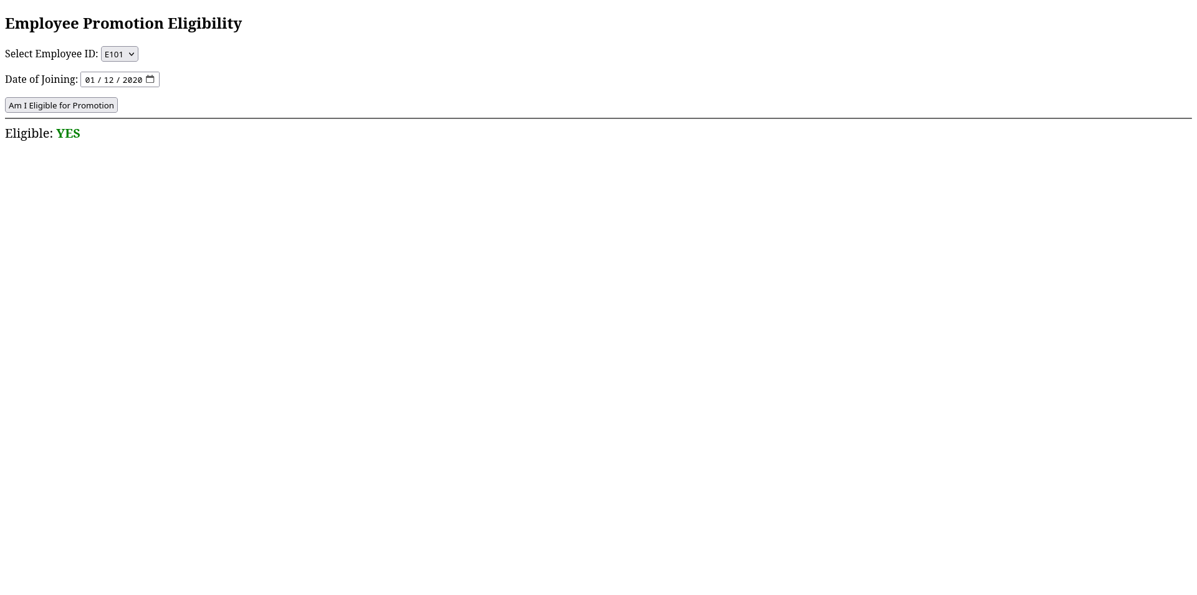
-

Q1.Create a web form which allows the teacher to enter the student details like name,
date of birth, address, contact number, email id and marks of English, Physics and
Chemistry. After filling all the information and on clicking submit button, details
should be added to a textarea displayed on the same page. Display the total
percentage of marks obtained in a label.
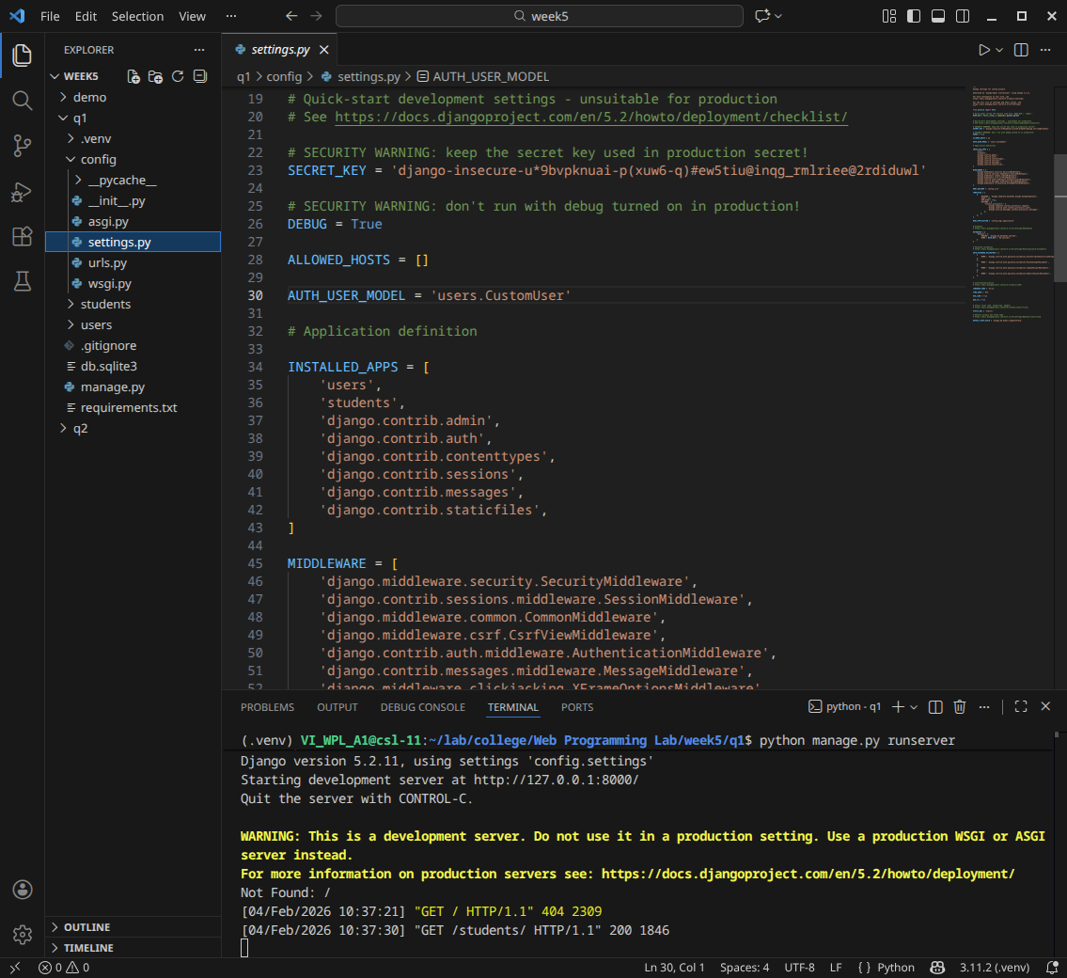
forms.py:
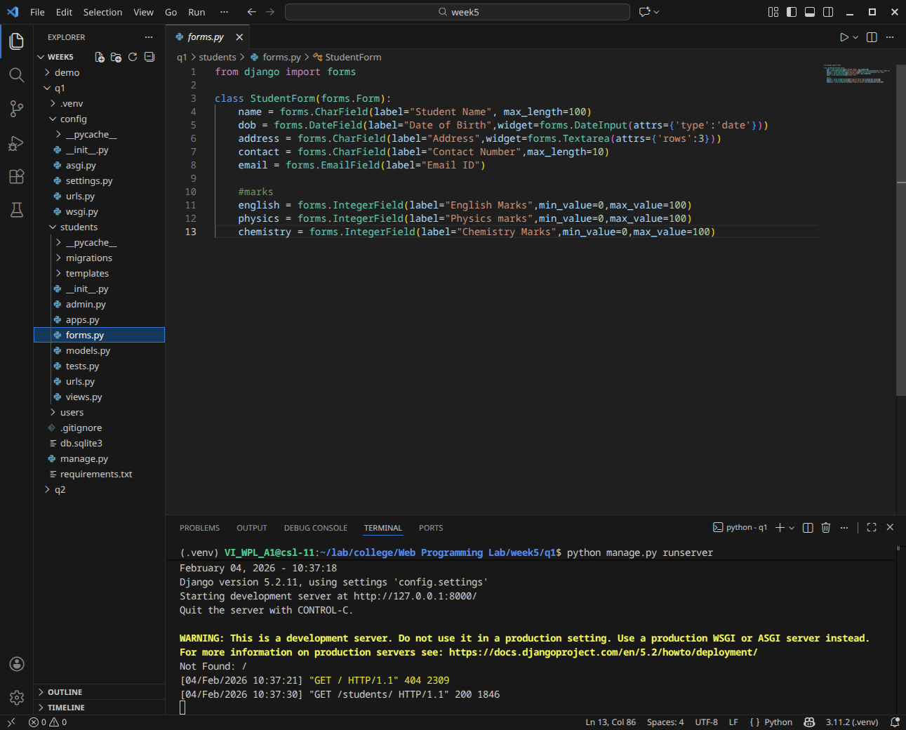
urls.py
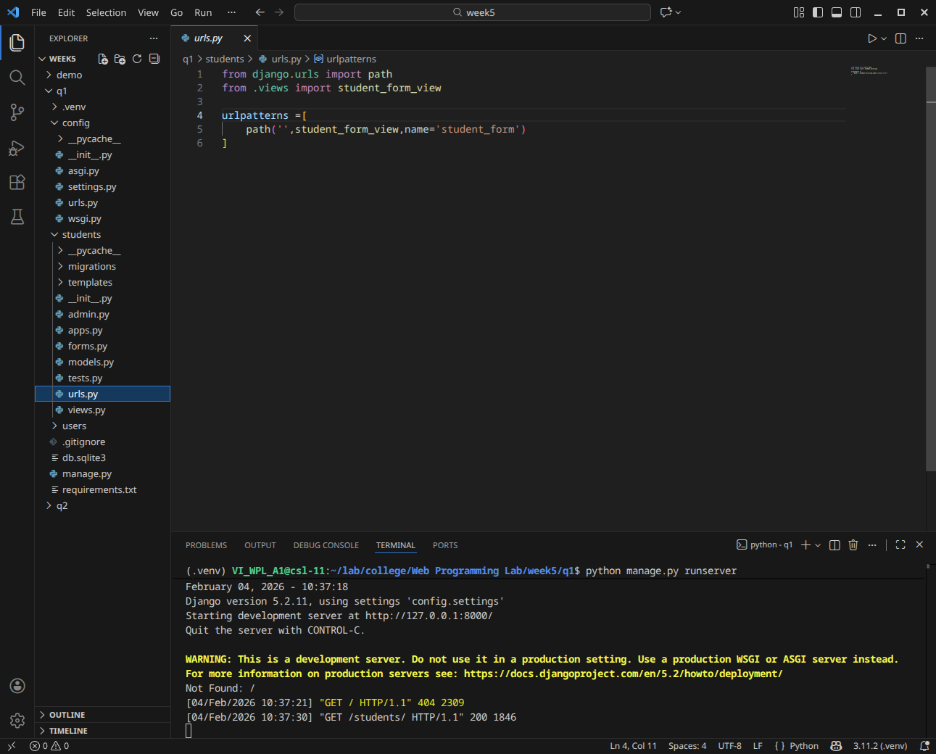
views.py
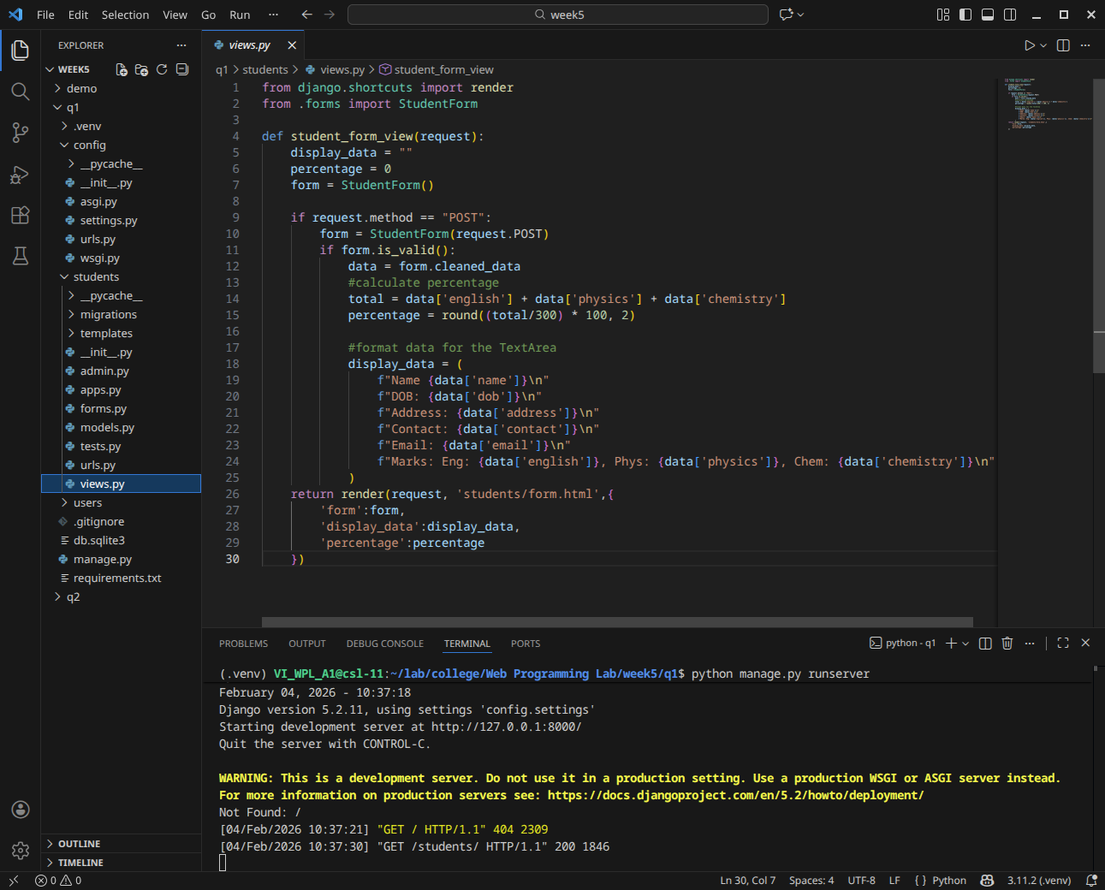
form.html
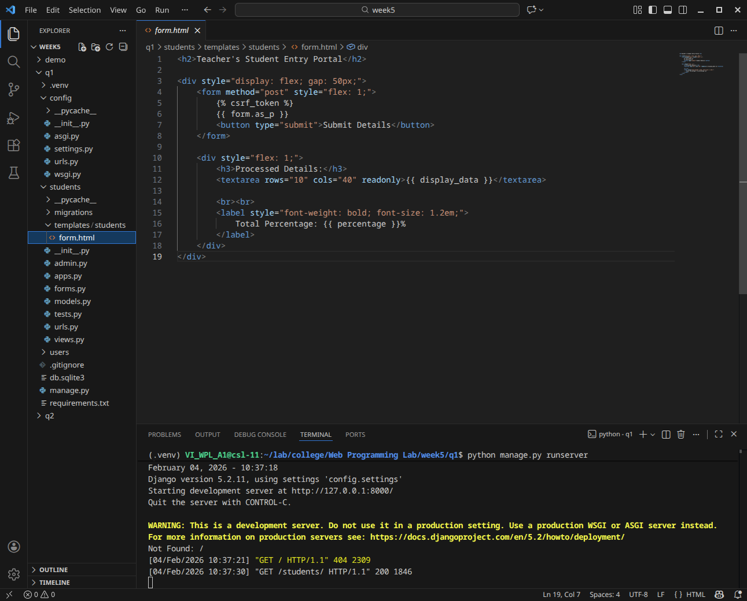
website
